**Assignment-Semiconductors**

**CO-1**

Q-1 Draw the atomic structure of Si atom. Consider a crystal with only Si atoms, draw the covalent bonding and indicate the covalent bond.

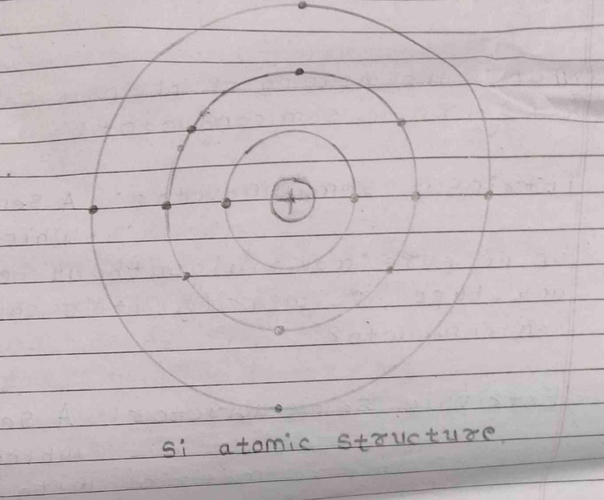

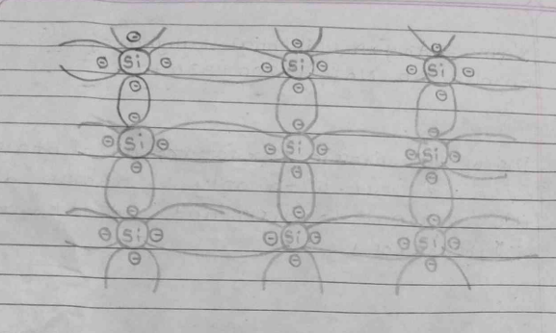

Q-2 What is the meaning of intrinsic semiconductor and extrinsic semiconductor?

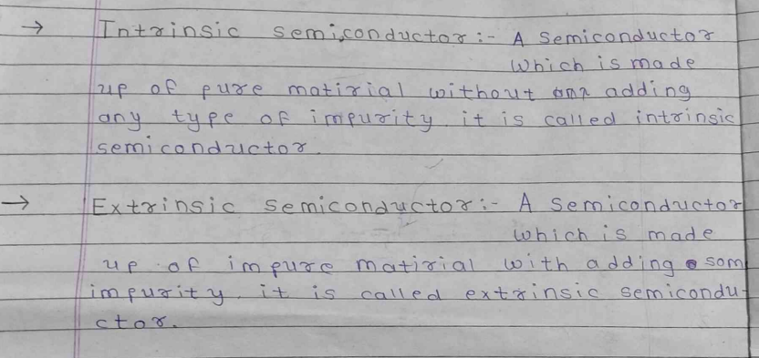

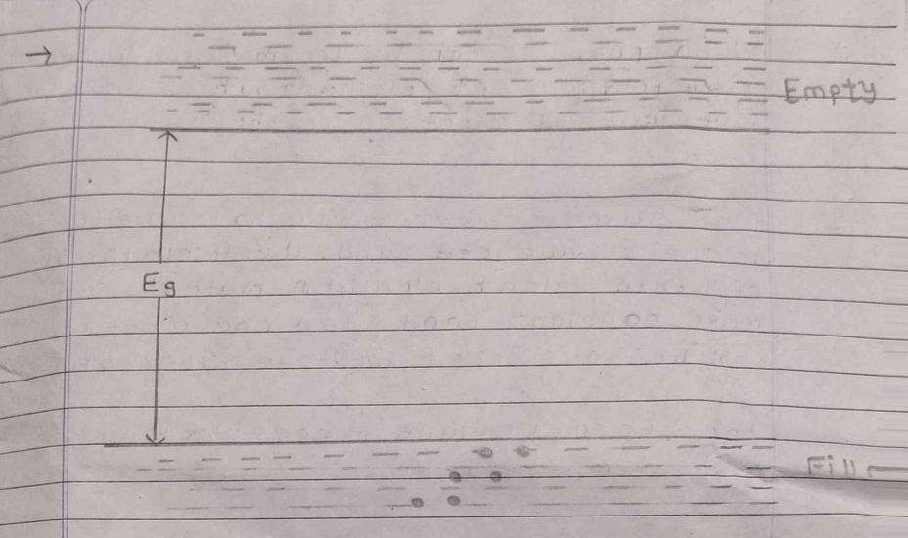Q-3 Draw the energy band diagram for intrinsic Si atoms when bounded together.

Q-4 Draw the energy band diagram for N-type semiconductor material and briefly explain that why do we have free electrons at room temperature?

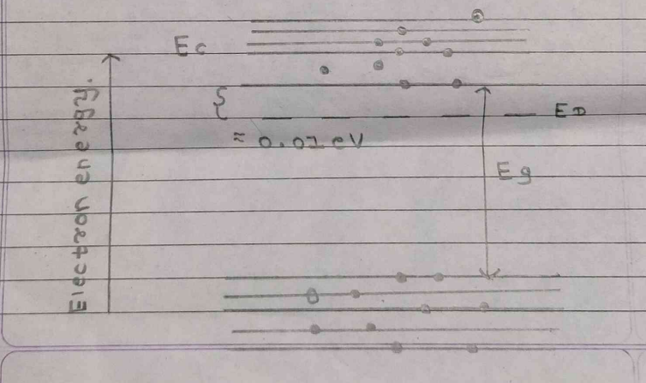

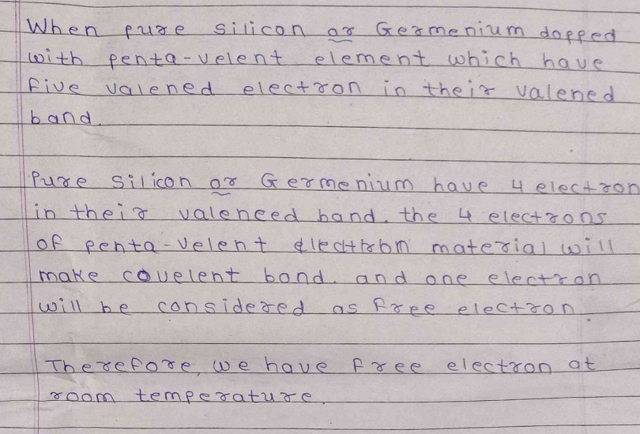

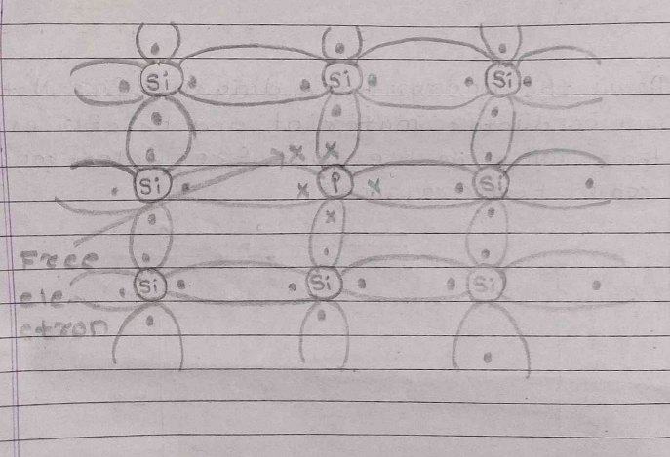

Q-5 Draw the energy band diagram for P-type semiconductor material and briefly explain its effect at room temperature?

